AFJROTC Report 2023
Nara Hernandez
2024-01-09

Purpose and Overview
School/JROTC Unit of interest: McKeesport Area Senior High School (PA-20162)
This report is made by request of Lt Col. Steven Hernandez and is designed to explore some outside-of-school factors that impact the McKeesport Area Senior High School students’ lives in order to make better informed adjustments to the academic plans in order to maximize positive impact of AFJROTC program/curriculum.
https://www.kaggle.com/datasets/thedevastator/2013-irs-us-income-data-by-zip-code?resource=download

Importing Data
Most of the following Data is taken from Niche https://www.niche.com/places-to-live/mckeesport-allegheny-pa/crime-safety/
200% or below the Federal Poverty Income Level as defined by the U.S. Department of Health and Human Services https://dced.pa.gov/housing-and-development/weatherization/income-eligibility/
Alternate source: https://www.dhs.pa.gov/Services/Assistance/Pages/FPIG.aspx
8 other AFJROTC units in the South West part of Pennsylvania selected from list of All AFJROTC Units https://www.google.com/maps/d/u/0/viewer?mid=1Zh9Kwbe3F2OM3kwG1QRfJdI-6dPDaW5J&hl=en_US&ll=40.50006939395599%2C-79.77411774444826&z=9
The units will be displayed by unit IDs. For clarity an asterisk * has been added to the beginning of the McKeesport Area Senior High School AFJROTC unit ID *PA20162

Economic Income
Median Income for our zipcode compared to national average and the 8 closest AFJROTC units within our state.
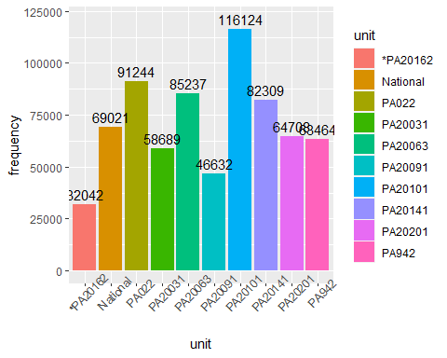
As can be seen in the visualization above, out of all the nearby AFJROTC units in the south west region of PA, the Mckeesport Area High School is the unit located in an area with the lowest median income.
The national median income for a household is $69,021 and the median household income in Mckeesport area is $32,042.
This is worth considering as the PA’s Department of Human Services’ 2023 Federal Poverty Income Guidelines state that $31,347.00 is the guideline marker for a 1 person household and that $42,398.00 is the guideline marker for a 2 person household.
Assuming all students at McKeesport Senior Area High School are an only child living with a single parent, it’s likely that even more than half of them would be living below the poverty line. However, in reality, they are most likely living in larger households under similar incomes.

Area Crime Rates
Outside Stress factors such as safety concerns can affect academic performance of students. Here are a few crime statistics taken from Niche for consideration. In the following categories, 2 of the nearby units have been removed because the data for them regarding crime rates was unavailable.
These crime rates are calculated annually per 100,000 residents.

Assault
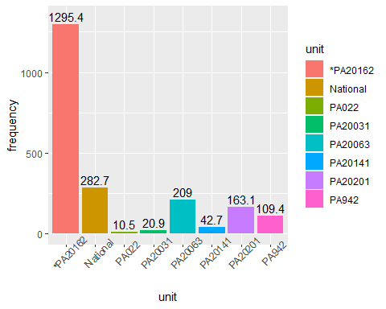
The rate of assaults in the McKeesport area where Unit PA-20162 is stationed is much higher than the national average and higher than the areas that the other units are situated in. It’s highly likely that the students at McKeesport have experienced/witnessed an assault, are exposed to violence regularly, have safety concerns relating to assaults, and/or have trauma related to assaults.

Murder
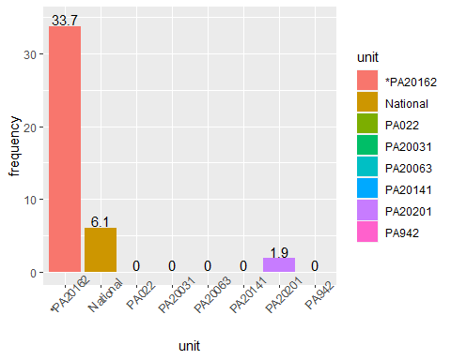
The rate of murders in the McKeesport area where Unit PA-20162 is stationed is much higher than the national average and higher than the areas that the other units are situated in. It’s highly likely that the students at McKeesport have have safety concerns relating to murders and/or have trauma related to murders.

Rape
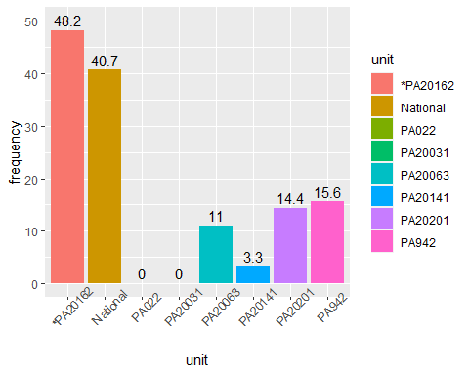
The rate of rapes in the McKeesport area where Unit PA-20162 is stationed is higher than the national average and higher than the areas that the other units are situated in. It’s highly likely that the students at McKeesport have have safety concerns relating to rape and/or have trauma related to rape.
Note: According to the Office for Victims of Crime (.gov) theft (or “Larceny-theft”) is defined as the unlawful removal of property. Burglary is defined as the unlawful entry into almost any structure with the intent to commit a crime inside. Robbery, on the other hand, is the violent theft of property or money.

Robbery
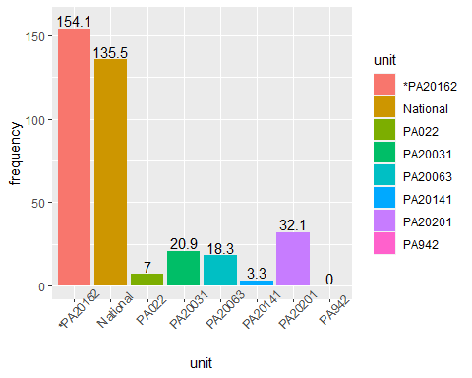
The rate of robberies in the McKeesport area where Unit PA-20162 is stationed is higher than the national average and higher than the areas that the other units are situated in. It’s highly likely that the students at McKeesport have have safety concerns relating to being robbed and/or have trauma related to robberies.

Burglary
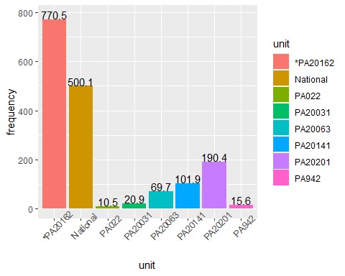
The rate of burglaries in the McKeesport area where Unit PA-20162 is stationed is higher than the national average and higher than the areas that the other units are situated in. It’s highly likely that the students at McKeesport have have safety concerns relating to burglaries and/or have trauma related to burglaries.

Theft
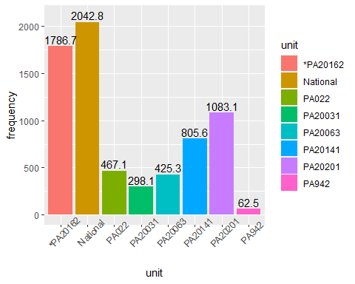
The rate of thefts in the McKeesport area where Unit PA-20162 is stationed is one of the few crime rates that are less than the national average. However, this crime rate is still higher than the areas that the other units are situated in.

Motor Vehicle Theft
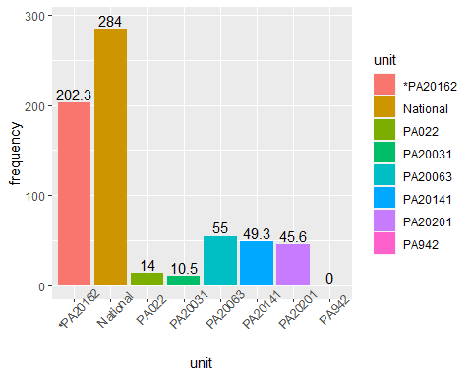
The rate of thefts in the McKeesport area where Unit PA-20162 is stationed is one of the few crime rates that are less than the national average. However, this crime rate is still higher than the areas that the other units are situated in.

Conclusion
This brief investigation into some of the economic and safety concerns in the McKeesport area shows that McKeesport students are in a particularly difficult environment and that adjusting the AFJROTC curriculumn to better address their needs would be worth considering.
If I were to further extend on this investigation, I would look at other factors such as McKeesport Senior Area High School’s academic performances in comparison to the other units in the state, factors in comparison with All AFJROTC units in the world, and also analyze other factors such as economic Mobility Variables (based on Raj Chetty’s research).

